SOLVING ONE STEP EQUATIONS
Pearson Edexcel - Thursday 4 June 2020 - Paper 2 (Calculator) Foundation Tier

Pearson Edexcel - Monday 12 November 2018- Paper 3 (Calculator) Foundation Tier

Pearson Edexcel - Thursday 2 November 2017 - Paper 1 (Non-Calculator) Foundation Tier

Pearson Edexcel – Specimen 1 - Paper 3 (Calculator) Foundation Tier

OCR Monday 11 November 2019 – Afternoon (Calculator) Foundation Tier

OCR Thursday 6 June 2019 – Morning (Non-Calculator) Foundation Tier
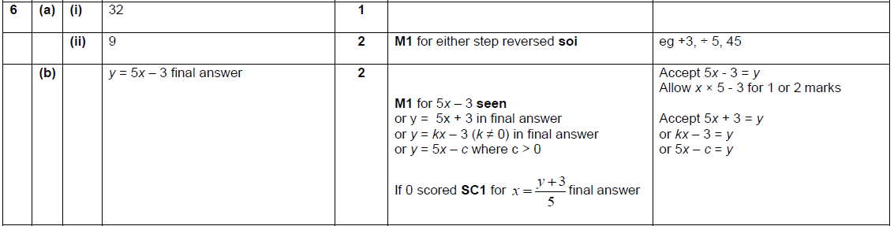

OCR Tuesday 11 June 2019 – Morning (Calculator) Foundation Tier

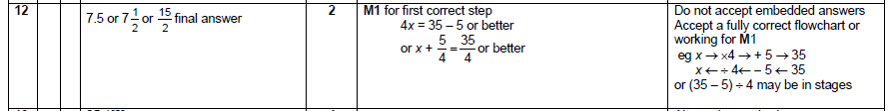

OCR Tuesday 6 November 2018 – Morning (Calculator) Foundation Tier

OCR Monday 24 May 2018 – Morning (Calculator) Foundation Tier
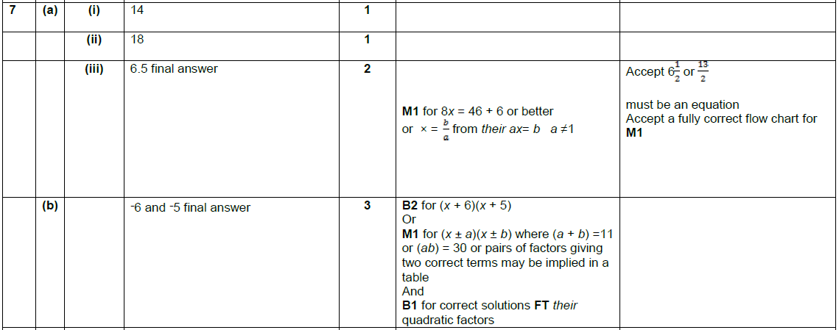

OCR Thursday 7 June 2018 – Morning (Non Calculator) Foundation Tier
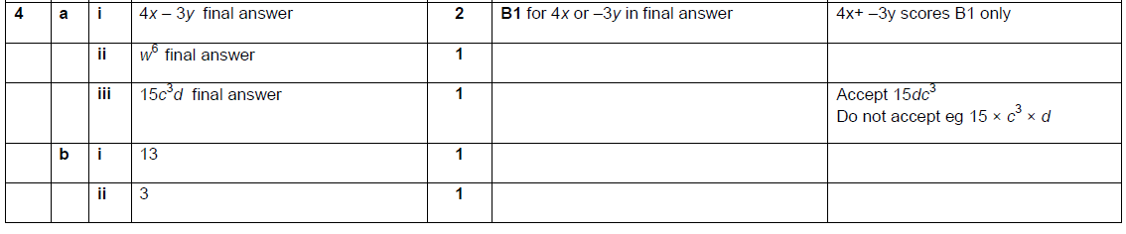

AQA Tuesday 21 May 2019 – Morning (Non-Calculator) Foundation Tier

AQA Thursday 11 June 2019 – Morning (Calculator) Foundation Tier

AQA Tuesday 6 November 2018 – Morning (Non-Calculator) Foundation Tier

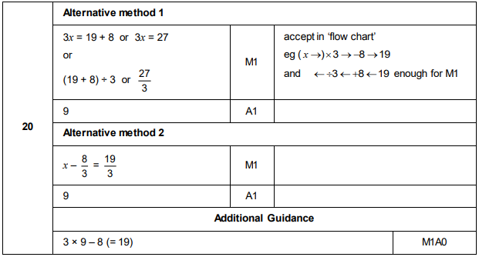
AQA Monday 12 November 2018 – Morning (Calculator) Foundation Tier

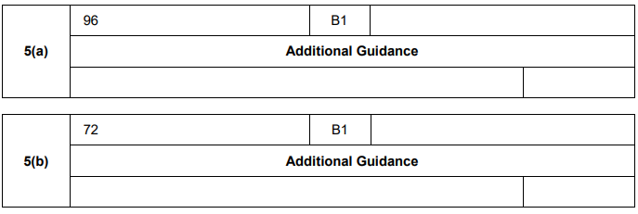
AQA Tuesday 12 June 2018 – Morning (Calculator) Foundation Tier

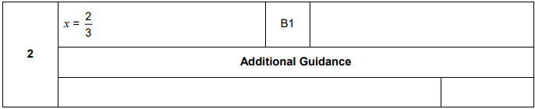
AQA Thursday 2 November 2017 – Morning (Non-Calculator) Foundation Tier

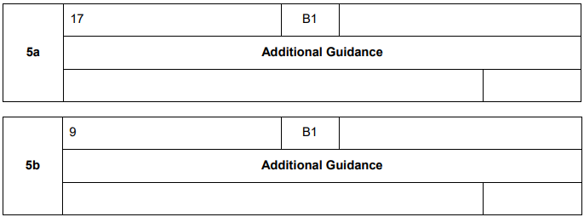
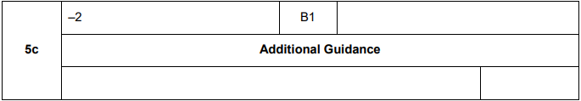
AQA Wednesday 8 November 2017 – Morning (Calculator) Foundation Tier

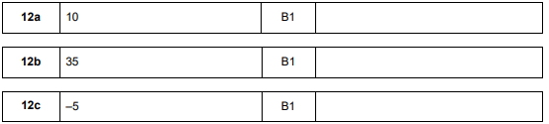

AQA Wednesday 8 November 2017 – Morning (Calculator) Foundation Tier

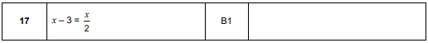

AQA Thursday 25 May 2017– Morning (Non-Calculator) Foundation Tier

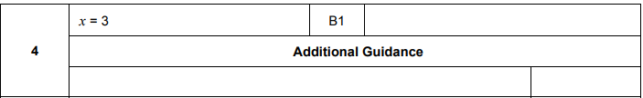
AQA Thursday 8 June 2017– Morning (Calculator) Foundation Tier

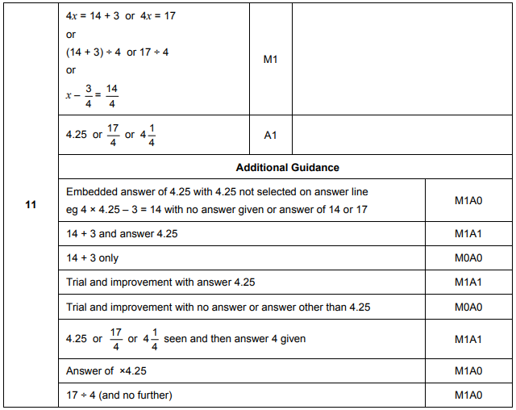
AQA Sample Paper 3– Morning (Calculator) Foundation Tier

